Good afternoon everyone,

I hope you are all well and looking forward to the summer! Please see below/attached for CIMG’s 2021 Year End Update.

CIMG Alumni Personal Updates
Below are the updates we’ve received from alumni over the last few months. Please email me with any personal updates you would like me to include in our next alumni newsletter at any time!

Adam Carll: Moving to Private Wealth Management at Goldman Sachs in Atlanta.
Grace and Tyler Evans: Welcomed the (potentially) first baby girl born to two CIMG alum, Mary Elise, on Thanksgiving Day Last year. Congrats!
Katie Smith: Joined Forestar Group as Director of Finance and Investor Relations in Dallas.
Scott Peters: Promoted to Principal at Tailwater Capital in Dallas.

Internship & Post-Graduate Placement
We have continued our success throughout the semester in securing interesting and high caliber internships in a variety of fields. Listed again below are all of the senior placements if anyone wants to reach out! Below are all additional undergrad placements with new additions highlighted in yellow.

Full-Time Placement:
Name | Institution | Role | City | State
Nick Ramos | 84.51° | Data Scientist | Cincinnati | OH
Jack Wronkowski | Barclays | Investment Banking Analyst | Menlo Park | CA
Melina Schaetz | Barclays | Investment Banking Analyst | Chicago | IL
Zach Newcomb | Barclays | Equity Research Associate | New York | NY
Santiago Diaz | Goldman Sachs | Investment Banking Analyst | New York | NY
Sarah Conrad | Goldman Sachs | Global Investment Research Analyst | New York | NY
Christine Marocchini | Goldman Sachs | Global Markets Analyst | New York | NY
E.V. Koslosky | Goldman Sachs | Global Investment Research Analyst | New York | NY
Johanna Mennona | Moelis & Co | Investment Banking Analyst | New York | NY
Michael Hincker | Point72 | Academy Associate | New York | NY
Lena Brysacz | The Boston Consulting Group | Associate | Atlanta | GA
Henry Kilpatrick | Venture for America | 2021 Fellow - Startup | TBD | TBD

Internship Placement:
Name | Institution | Role | City | State
Marcus Roberts | Arlington Capital Advisors | Investment Banking Analyst | Birmingham | AL
Thomas Bugg | Baird | Investment Banking Analyst | Washington | D.C.
Emmaline Teska | Citi | Sophomore Leadership Program - Capital Markets Analyst | New York | NY
Jack Callahan | Cook & Bynum | Research Intern | Birmingham | AL
Jacob Hirth | Deutsche Bank | Investment Banking Analyst | Jacksonville | FL
Sam Barnes | Eastside Partners | Business Development Analyst | Huntsville | AL
Jack Denning | Flipstone Technology Partners | Software Development Intern | Austin | TX
Ellery Hill | GWI - Baupost Group | Summer Intensive Student | Boston | MA
Connor Dessert | Goldman Sachs | Global Investment Research Intern | New York | NY
Cory Milsap | Goldman Sachs | Controllers Engineering Intern | Dallas | TX
Samantha Monello | Intuitive | Financial Analyst Intern | Sunnyvale | CA
Reid Blackmon | Morgan Stanley | Investment Banking Analyst | New York | NY
Matthew DeBrunner | NASA | Pathways Engineering Intern | Huntsville | AL
Ben Silvey | PJ Solomon | Investment Banking Analyst | New York | NY
Nick Parsons | Point72 | Academy Summer Analyst | New York | NY
Zachary Collins | Regions Financial Corporation | Financial Analyst | Birmingham | AL
Ehlana McRanor | Stifel | Summer Analyst | New York | NY
Walt Shelton | U.S. House of Representatives | Congressional Intern | Washington | D.C.
William Ortmayer | Vulcan Value Partners | Equity Research Intern | Birmingham | AL
Nathan Ellis | Vulcan Value Partners | Client Services Intern | Birmingham | AL
Brett Bonikowski | Vulcan Value Partners | Equity Research Intern | Birmingham | AL
Erik Buinevicius | Vulcan Value Partners | Data Science Intern | Birmingham | AL
Portfolio Update
Portfolio Summary
Market Value of Equities | $ 1,285,478
Mint Shares Balance (Cash Equivalent) | $ 257,847
Cash Balance | $ 55,076
Portfolio % Cash Position | 19.6%
Market Value of Portfolio | $ 1,598,401
Intrinsic Value of Portfolio (ex-cash) | $ 1,529,722
Equity Portfolio V/P (ex-cash) | 1.19
CIMG Performance Since Inception | 14.7%
SPY Performance Since Inception | 12.9%
CIMG Performance YTD | 11.6%
SPY Performance YTD | 13.4%

This has also been a great year for our portfolio, which has returned 12% YTD, and is closing in on $1.6 million in market value! Going forward, the board is focusing on maintaining a high quality watchlist and being diligent on updating portfolio companies. To keep a high quality watchlist, the board is currently testing a dual decision strategy; either a buy or a do not invest. If the IDC chooses not to invest in a business due to margin of safety, the committee can choose to watchlist the business. They will then have to maintain it as if it is a portfolio company in an attempt to quickly enter into positions into high quality businesses once we are comfortable with the price. We hope this strategy allows us to keep watch of not only our portfolio companies, but for each committee to watch a few businesses at a time, waiting for optimal entry points.

Since our last update, CIMG initiated positions in Nike Inc [NKE] and United Health Group [UNH]. Despite strong pitches from committees on Adobe [ADBE], Lockheed Martin [LMT], and Smile Direct Club [SDC], we were unable to initiate positions due to narrow margins of safety.

If you would like to know more about any of these decisions, Investment Decision Committee Opinions are available by request.

New Member Training Program
We were thrilled to finish off our latest New Member Training Program with strong pitches from all ten of our new members. New committee placements are listed below!

Financials: Walt Shelton and Sami Krutz
Healthcare: Forrest Roy and Will Coleman
Industrials and Energy: Alek Ledvina and Cole Reynolds
Technology, Media, and Telecommunications: Carter Murray and Drew Goodwin
Aerospace, Defense, and Transportation: Ehlana McRanor and Louis Vacca

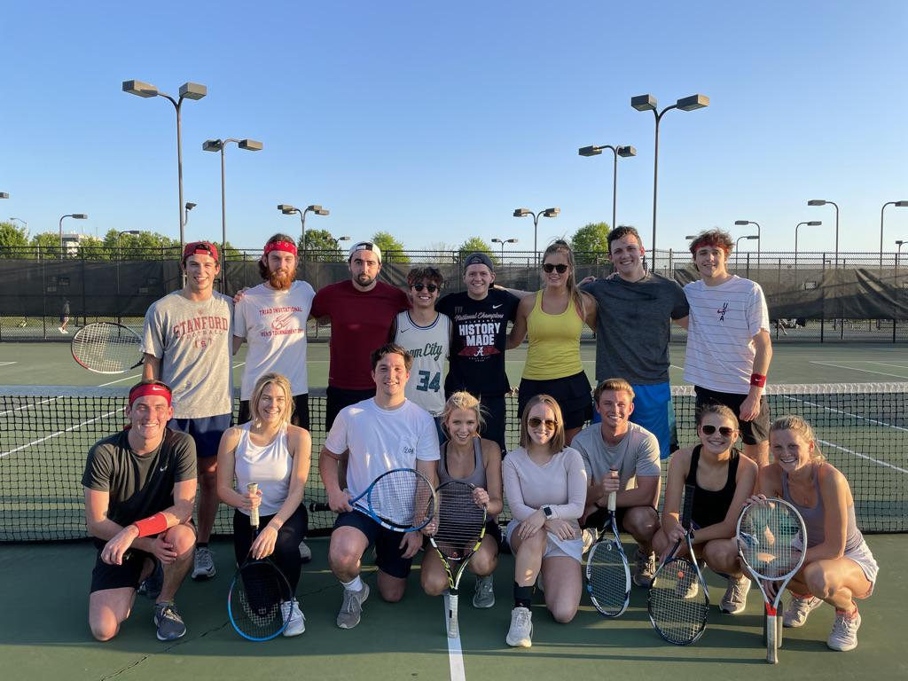

CIMG Tennis Tournament
An idea first floated last year by Sydney Gabrielson and Jeff Jones came true as CIMG had it’s first double elimination tennis tournament this past month. What will hopefully become an annual tradition was won by Nick Parsons and Erik Buinevicius. Some of us certainly have some practice to do before next year!

Final Note
I want to once more extend a huge thank you to Nick Ramos, Michael Hincker, Zach Newcomb, and Christine Marocchini for their excellent work as a BOD in keeping CIMG in such great shape through tough times. I hope to report back at the start of next year after our return to in person meetings, and Bryant Denny at max capacity. The group is looking to continue improving our research process, slide decks, and pitching abilities and I feel that the group has never been in a better place to do so. To close out this year, I want to thank the entire senior class for their invaluable contributions to CIMG over the last four years. Congrats to Henry Kilpatrick, Nick Ramos, Michael Hincker, Santiago Diaz, Jack Wronkowski, Zach Newcomb, Christine Marocchini, Lena Brysacz, Johanna Mennona, Evie Koslosky, Melina Schaetz, and Sarah Conrad for graduating from UA to move on to bigger and better things. Welcome to the exclusive CIMG alumni club and remember to keep in touch! Please reach out to me at basilvey@crimson.ua.edu or at 210-854-0151 with any questions or comments.

Have a great summer and Roll Tide!

